# Power Pages Lab - Known issues

1. **Error msg that enhanced data model isn’t enabled.**

This is a caching issue. Ways to fix the issue:

* Ctrl+F5 on the browser window
* Navigate to PowerApps homepage and then navigate back to Power Pages

1. NL2Page or NL2Theme returns “There was a problem with this description. Rewrite it and try again”.

Things to try:

* Re-enter the prompt. It might have timed out because internet is slow.
* Open homepage and click “Edit” to re-open the site in Studio. Re-enter the prompt
* Last option, copy and paste the highlighted parameter and add it to the participant’s URL. This will switch side car to I-API. If you do this, then for step 5 create a form using Copilot in the lab, don’t enter prompt in Copilot pane. Instead, add a new section to the page and add the “Form” control. Enter the prompt in the Contextual Copilot.

<https://make.powerpages.microsoft.com/e/e7d8bf6b-a367-ea0d-bf69-12ddb9e33505/sites/97bcbff4-bf4b-ee11-be6f-0022482724a8/pages?ecs.PortalsMakerExperiences.PortalsMakerExperiences.enableOfficeSidecar=true&ecs.PortalsMakerExperiences.PortalsMakerExperiences.enableCdsContext=true&ecs.PortalsMakerExperiences.PortalsMakerExperiences.enableKeepItMode=true#webpages/27c8aef2-bf4b-ee11-be6f-000d3a1b05d7>



1. **VSCode Copilot** – can’t get phone field id from Design Studio, preview the page, and in the C2 RT experience, right click on phone field -> Inspect.

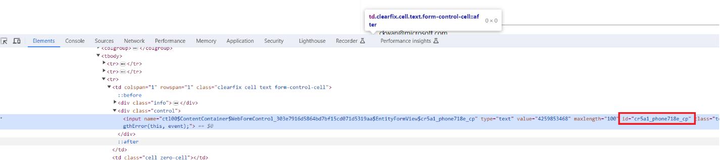

1. **VSCode Copilot doesn’t generate the expected code.**

Occasionally, VSCode Copilot generates a different variation of the code. This happens if the maker doesn’t use the prompt provided. Double check the prompt.

If this doesn’t fix the problem, here the code:

if (window.jQuery) {  
 (function ($) {  
 $(document).ready(function () {  
 if (typeof (Page_Validators) == 'undefined') return;  
 // Create new validator  
 var newValidator = document.createElement('span');  
 newValidator.style.display = "none";  
 newValidator.id = "phoneValidator";  
 newValidator.controltovalidate = "phone";  
 newValidator.errormessage = "<a href='#phone_label' referencecontrolid='phone ' onclick='javascript:scrollToAndFocus(\"phone _label\",\" phone \");return false;'>Phone is not in a valid format.</a>";  
 newValidator.validationGroup = ""; // Set this if you have set ValidationGroup on the form  
 newValidator.initialvalue = "";  
 newValidator.evaluationfunction = function () {  
 var value = $("#phone").val();  
 var phoneRegex = /^[0-9]{10}$/;  
 if (!phoneRegex.test(value)) {  
 return false;  
 } else {  
 return true;  
 }  
 };  
  
 // Add the new validator to the page validators array:  
 Page_Validators.push(newValidator);  
  
 });  
 }(window.jQuery));  
}